[Top](http://tts.tmooc.cn/ttsPage/LINUX/NSDTN201904/NETWORK/DAY02/CASE/01/index.html" \l "page_top_case)

# NSD NETWORK DAY02

1. [案例1：划分VLAN](http://tts.tmooc.cn/ttsPage/LINUX/NSDTN201904/NETWORK/DAY02/CASE/01/index.html" \l "case1)
2. [案例2：多交换机VLAN的划分](http://tts.tmooc.cn/ttsPage/LINUX/NSDTN201904/NETWORK/DAY02/CASE/01/index.html" \l "case2)
3. [案例3：配置trunk中继链路](http://tts.tmooc.cn/ttsPage/LINUX/NSDTN201904/NETWORK/DAY02/CASE/01/index.html" \l "case3)
4. [案例4：链路聚合配置](http://tts.tmooc.cn/ttsPage/LINUX/NSDTN201904/NETWORK/DAY02/CASE/01/index.html" \l "case4)
5. [案例5：配置静态路由](http://tts.tmooc.cn/ttsPage/LINUX/NSDTN201904/NETWORK/DAY02/CASE/01/index.html" \l "case5)
6. [案例6：三层交换机基本配置](http://tts.tmooc.cn/ttsPage/LINUX/NSDTN201904/NETWORK/DAY02/CASE/01/index.html" \l "case6)

## 1 案例1：划分VLAN

### 1.1 问题

在交换机上创建以下VLAN，按照拓扑图-1将端口加入到指定的VLAN并配置服务器IP地址，实现同VLAN主机的通信

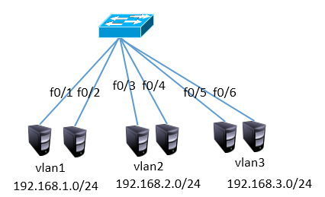

图-1

### 1.2 步骤

实现此案例需要按照如下步骤进行

步骤一：创建vlan，并将接口加入

由于默认情况下所有接口都在VLAN1中，且VLAN1默认就存在，所以只需要配置VLAN2和VLAN3即可

1. <Huawei>system-view
2. [Huawei]vlan batch 2 3            //创建VLAN2、3
3. [Huawei]port-group 1
4. [Huawei-port-group-1]group-member Ethernet0/0/3 Ethernet0/0/4
5. [Huawei-port-group-1]port link-type access
6. [Huawei-port-group-1]port default vlan 2
7. [Huawei-port-group-1]quit
8. [Huawei]port-group 2
9. [Huawei-port-group-2]group-member Ethernet0/0/5 Ethernet0/0/6
10. [Huawei-port-group-2]port link-type access
11. [Huawei-port-group-2]port default vlan 3

## 2 案例2：多交换机VLAN的划分

### 2.1 问题

通过配置交换机实现图-2中的同VLAN主机互通

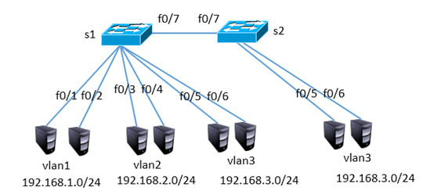

图-2

### 2.2 步骤

注：以下配置需要在案例1的基础上完成

步骤一：创建vlan，并将接口加入

1）S1配置

1. [Huawei]interface Ethernet0/0/7
2. [Huawei-Ethernet0/0/7] port link-type access
3. [Huawei-Ethernet0/0/7] port default vlan 3

2）S2配置

1. <Huawei>system-view
2. [Huawei]vlan 3            //创建VLAN3
3. [Huawei]port-group 1
4. [Huawei-port-group-1]group-member Ethernet0/0/5 to Ethernet0/0/7
5. [Huawei-port-group-1]port link-type access
6. [Huawei-port-group-1]port default vlan 3

## 3 案例3：配置trunk中继链路

### 3.1 问题

通过配置实现跨交换机的同VLAN通信，如图-3所示

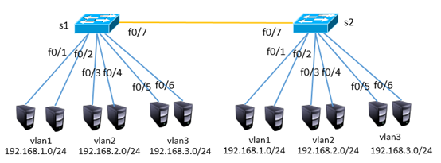

图-3

### 3.2 步骤

注：以下配置需要在案例2的基础上完成

步骤一：配置trunk，放行所有vlan

1）S1配置

1. 如果接口被改动过，则需要恢复默认配置
2. [Huawei] clear configuration interface Ethernet0/0/7
3. [Huawei]interface Ethernet0/0/7
4. [Huawei-Ethernet0/0/7]port default vlan 1
5. [Huawei-Ethernet0/0/7]port link-type trunk
6. [Huawei-Ethernet0/0/1]port trunk allow-pass vlan all

2）S2配置

1. <Huawei>system-view
2. [Huawei]vlan 2         //创建VLAN2
3. [Huawei]port-group 1
4. [Huawei-port-group-1]group-member Ethernet0/0/3 Ethernet0/0/4
5. [Huawei-port-group-1]port link-type access
6. [Huawei-port-group-1]port default vlan 2
7. [Huawei]interface Ethernet0/0/7
8. [Huawei-Ethernet0/0/7]port default vlan 1
9. [Huawei-Ethernet0/0/7]port link-type trunk
10. [Huawei-Ethernet0/0/1]port trunk allow-pass vlan all

## 4 案例4：链路聚合配置

### 4.1 问题

参照图-4将两台交换机的f0/1-f0/2接口互联，并实现高可用



图-4

### 4.2 步骤

步骤一：创建链路聚合接口，并捆绑物理接口

1）S1配置

1. [Huawei]interface Eth-trunk 1
2. [Huawei- Eth-trunk1]trunkport ethernet 0/0/1 0/0/2
3. 如果接口被改动过，则需要恢复默认配置
4. [Huawei] clear configuration interface Ethernet0/0/1

2）S2配置

1. [Huawei]interface Eth-trunk 1
2. [Huawei- Eth-trunk1]trunkport ethernet 0/0/1 0/0/2

## 5 案例5：配置静态路由

### 5.1 问题

按照图-5拓扑结构配置接口ip地址并通过静态路由实现全网互通

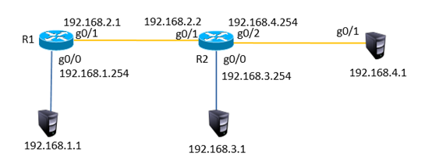

图-5

### 5.2 步骤

步骤一：配置ip地址，添加静态路由

1）R1配置

1. <Huawei>system-view
2. [Huawei]interface GigabitEthernet 0/0/0
3. [Huawei-GigabitEthernet0/0/1]ip address 192.168.1.254 24
4. [Huawei-GigabitEthernet0/0/1]quit
5. [Huawei]interface GigabitEthernet 0/0/1
6. [Huawei-GigabitEthernet0/0/1]ip address 192.168.2.1 24
7. [Huawei]ip route-static 192.168.3.0 24 192.168.2.2
8. [Huawei]ip route-static 192.168.4.0 24 192.168.2.2

2）R2配置

1. <Huawei>system-view
2. [Huawei]interface GigabitEthernet 0/0/0
3. [Huawei-GigabitEthernet0/0/1]ip address 192.168.3.254 24
4. [Huawei-GigabitEthernet0/0/1]quit
5. [Huawei]interface GigabitEthernet 0/0/1
6. [Huawei-GigabitEthernet0/0/1]ip address 192.168.2.2 24
7. [Huawei-GigabitEthernet0/0/1]quit
8. [Huawei]interface GigabitEthernet 0/0/2
9. [Huawei-GigabitEthernet0/0/1]ip address 192.168.4.254 24
10. [Huawei]ip route-static 192.168.1.0 24 192.168.2.1

## 6 案例6：三层交换机基本配置

### 6.1 问题

按照图-6的拓扑结构配置ip地址并通过三层交换实现VLAN间通信

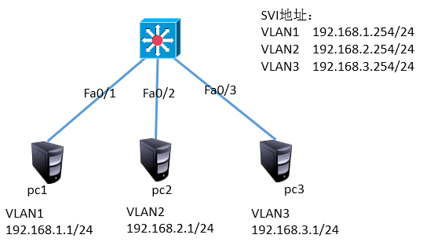

图-6

### 6.2 步骤

步骤一：创建vlan，并配置虚拟接口的ip

三层交换机配置

1. [Huawei]vlan batch 2 3
2. [Huawei]interface Vlanif 1
3. [Huawei-Vlanif1]ip address 192.168.1.254 24
4. [Huawei]interface Vlanif 2
5. [Huawei-Vlanif1]ip address 192.168.2.254 24
6. [Huawei]interface Vlanif 3
7. [Huawei-Vlanif1]ip address 192.168.3.254 24
8. [Huawei]interface G0/0/2
9. [Huawei-GigabitEthernet0/0/2] port link-type access
10. [Huawei-GigabitEthernet0/0/2] port default vlan 2
11. [Huawei]interface G0/0/3
12. [Huawei-GigabitEthernet0/0/2] port link-type access
13. [Huawei-GigabitEthernet0/0/2] port default vlan 3